App name: Squeeze Can

Technical specifications:
- screen orientation: vertical
- number of languages: German, English
- ux/ui link on figma:
https://www.figma.com/file/JWCpDsKDlfp6rrvlKuTs7b/Squeeze_%D0%A1an?node-id=0%3A1
- sound link:
https://drive.google.com/drive/folders/1i4ddgoAc4MNhskwZBZdgNvPwmaVH6NIV?usp=sharing

- Main Menu screen:
- Application name
- “Game” button (opens the “Gameplay” screen)
- “Settings” button (opens the “Settings” screen)
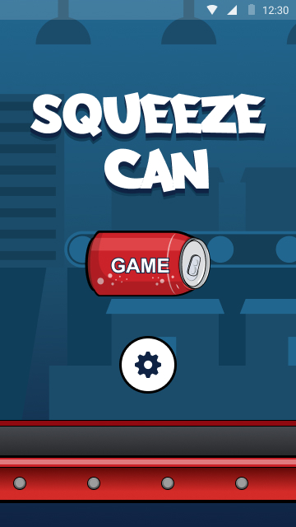
- Settings screen:
- Back button (returns to Main Menu screen)
- Settings caption;
- "Vibration" button and on / off switch (enables / disables device vibration when clicked)
- "Flag" icon with the current language and the "Select" button (when a language is selected, the interface changes to the corresponding language);
- The "Delete data" button (a window pops up with the inscription "Delete all profiles and application results?" With a choice Yes / No), erases all profiles and gameplay results;
- Privacy Policy button (opens the Policy screen) Policy
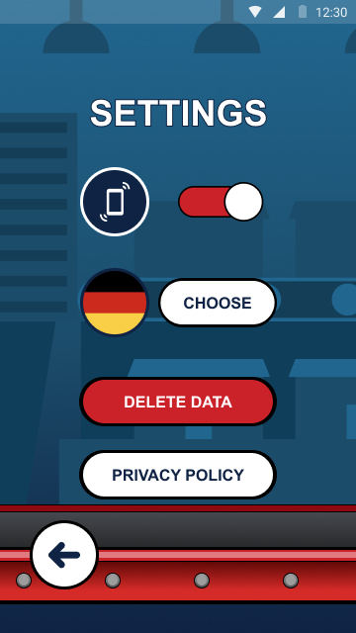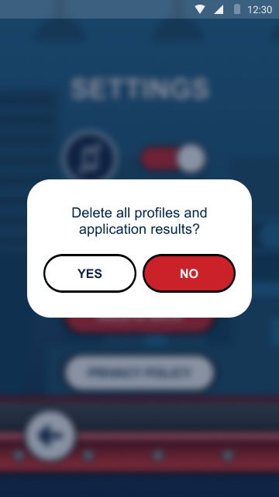

- PP Screen:
Displays the webview on the privacy policy.
- Back button (returns to the main menu);
- Refresh button;
- A screen displaying a link to a document;
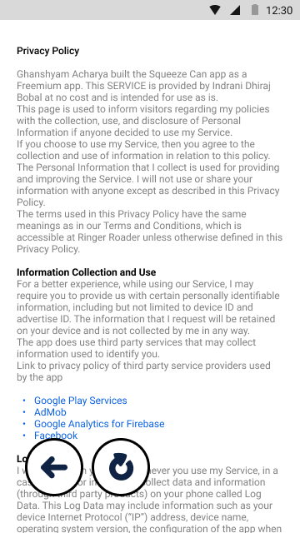

- Profile selection Screen:
The user is presented with a scoreboard. They are displayed in decreasing order (from shortest time to longest). Each location has a display of a profile photo, its name and the time it took it to complete the task in the game.
- "Back" button (returns to the "Main Menu" screen)
- Scoreboard displaying prize places from 1 to 3 (seat number; profile photo; profile name; time - points);
- Buttons for switching the list with profiles (scrolls through the list of profiles);
- Displaying the current profile (photo and name), which will play the next game session;
- Select button (opens the Gameplay screen);
- "New" button (opens the "Create Profile" screen);
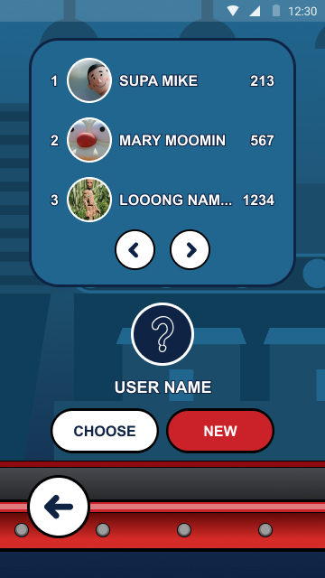

- Screen “Create profile”:
The user is informed about the permission of the application to give access to the camera; media files and keyboard. Here the user creates his profile, which can then be displayed for gameplay statistics.
- Back button (returns to the Select Profile screen)
- Caption “Take a Photo”;
- "+" Button (after creating a photo, the taken photo is displayed on this button);
- The inscription “Write the name”;
- "Name" button (opens the keyboard with the name input, after confirmation displays the entered name on the button);
- "Finish" button (becomes clickable only after filling in the profile; returns to the "Select Profile" screen with the display of the newly created profile);
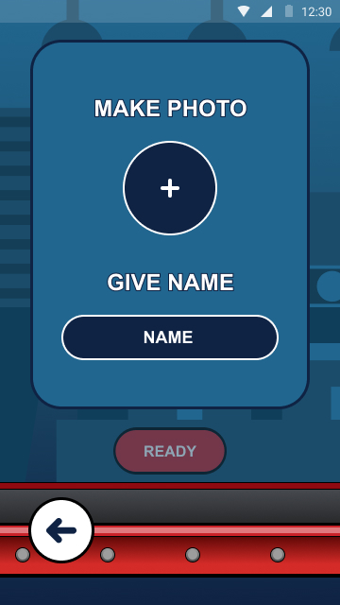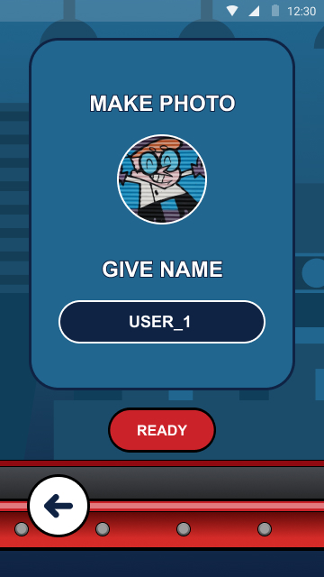

- Screen "Gameplay":
The task of the player is to squeeze the cans with the images of football players. The cans conveyor moves from right to left with cans randomly spawning. To step on the conveyor belt, the player taps on the screen. The leg presses at the same speed.
There are two types of cans on the conveyor: football players and referees. When squeezing cans with football players, the player gets 1 point. If the foot hits the banks with the referee, the game ends. For every 5 points scored, the conveyor moves faster.
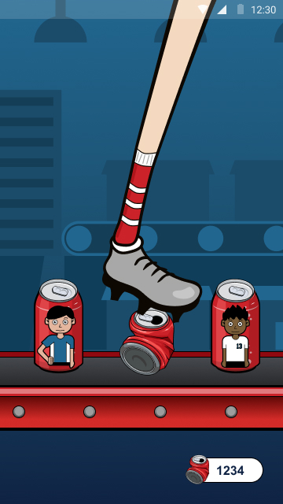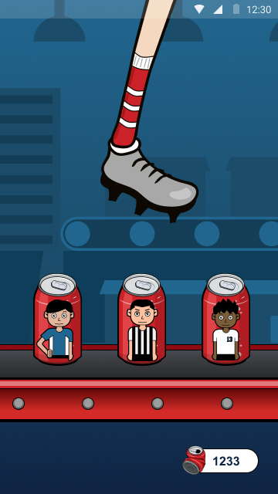

- End Game Screen:
Displays the results of the current game session that has ended.
- “End of the Game” inscription;
- "Restart" button (starts anew the game session);
- Menu button (returns to the Main Menu screen);
